Cincinnatus Central School Computer Work Study TC3 College Credit
CSS 212 Help Desk and User Support
CSS 112 Hardware Repair and Maintenance

40 Week Course by Nicole Rice, Director of Technology
Specifications
- 1 unit of credit - regents or local
- May be enrolled for four years for a total of 4 local credits and 6 College Credits under TC3 College Now

Qualifications
- Grade 9-12 student
- Students are interviewed and hired by the District and BOE approved
- Students must complete a 6-week internship period before being approved into the program
- Strong interest in learning and working with computers, along with independent thinking skills in using and troubleshooting computer hardware and software
- Trustworthy

Course Overview
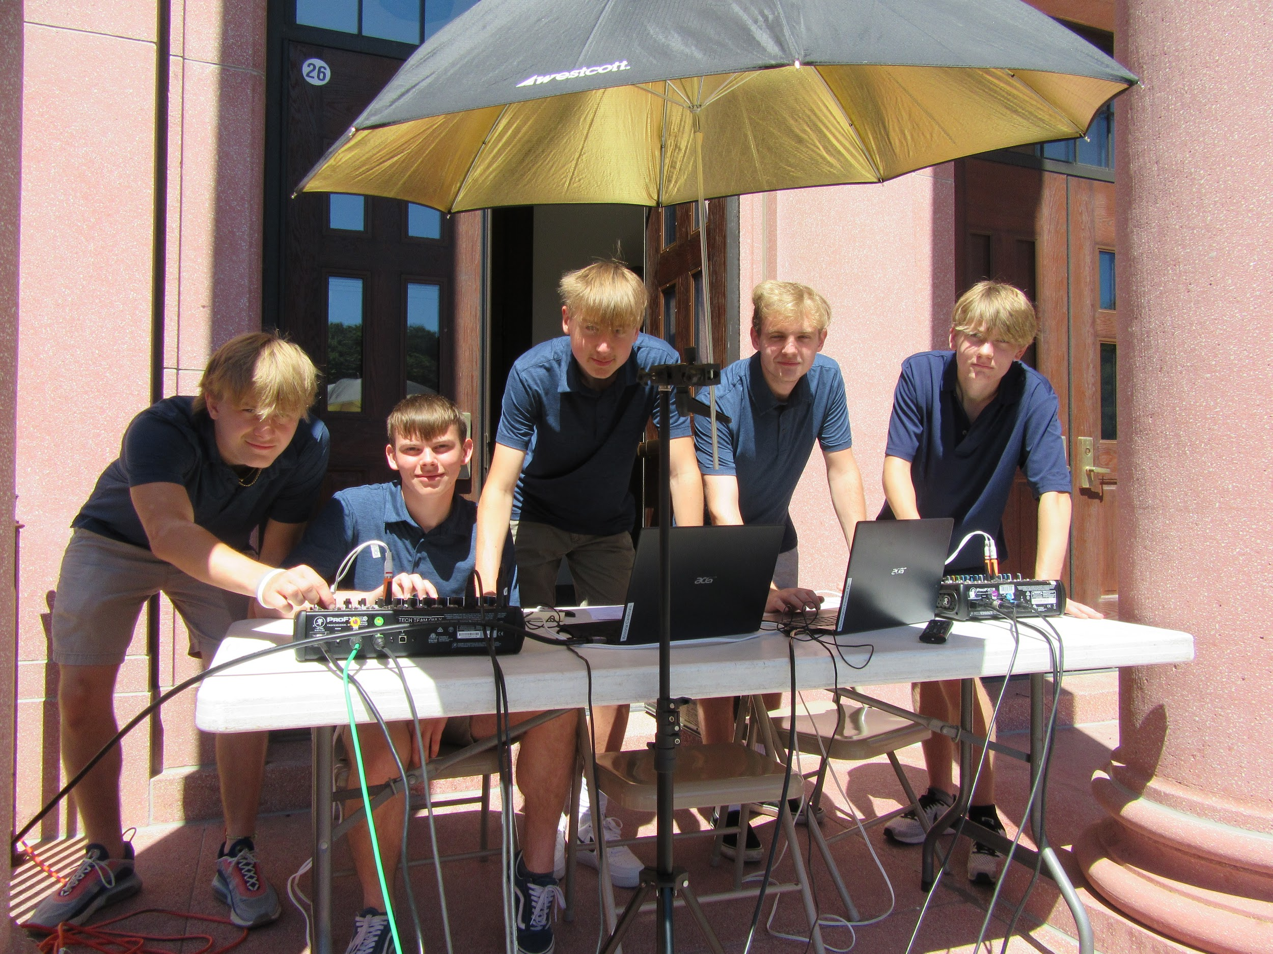
The Cincinnatus Central School District needed resident know-how for maintaining and evolving the school network. The computer department responded with training for students who had a strong interest in learning everything they could about computers, which inspired a help desk and user support program where students worked for course credit. The results being a hands-on course that earns one-unit of credit for every 40-weeks worked towards the 5-unit program in computers. Students become a member of the technical support department to assist in keeping the district's hardware and software running successfully and also part of a team that helps students, teachers, and staff with technical support. Students are part of the technical support team who work for the network administrator/teacher to maintain the school network, classroom and office computers, Chromebooks, computer labs, iPads, tablets, school website, school yearbook and newspaper production equipment, and any devices attached to the school network. This also includes morning announcement setup and DJing all school dances. One student may enroll in computer work study for four years with a maximum of 4 units of credit earned.

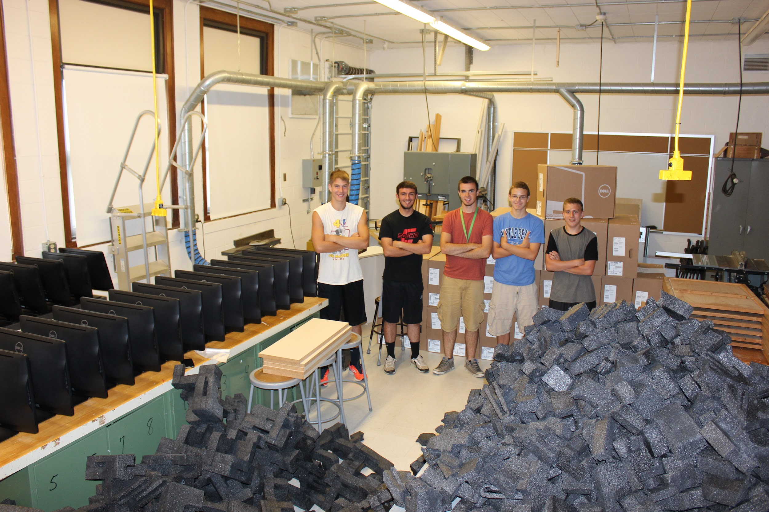
The computer work study program is an electronic learning model that combines instructor training and support, online learning with hands-on tasks, software and hardware troubleshooting, and participation in a job setting, that teaches students to configure, build, and maintain computer networks. From basic to advanced networking skills, the program prepares students for lifelong opportunities in the real work place. Students do everything from unpacking computers, inventorying and configuring equipment for online use, Drones for flying, 3 D printers and laser cutters, plus helping end users with software such as multimedia presentations, Zooms, Google Meets, email, Microsoft Office, STEAM lab setup, eSports lab configuration, digital cameras, live streaming school events and sports including all sound and video for high school graduation, iPhone setup and backup maintenance, and much more. It is a shift towards career-integrated academics that blends future workforce needs in a manner that delivers well-balanced graduates.

To ensure that technology-rich and advanced networking skills are delivered, a personalized learning environment is required where only a few students are enrolled in the program each year. Students will be asked to interview for the work before being enrolled officially into the course. The district superintendent has the final approval before a new person becomes part of the technical support team because network security is so important. The partnerships and alliances that build this ecosystem between the computer department and computer work study students should enable young people to keep pace in a global economy that is evolving on Internet time. This program empowers students to solve technology problems in their schools and communities that lead to offering them multiple exit points and paths to success equipping students for a variety of high-tech education and career options.

Job Description Computer Work Study – Student Computer Technician

Under supervision of the network administrator/teacher, student computer technicians build and maintain the computer network used by students, teachers, and staff in our school. Networked computers allow users to send email and to share data, computer applications, and Internet connections. As the school network grows with more computers and computerized equipment the demand for skilled computer network technicians also grows.

As a Computer Work Study Student for the District’s Technology Director/Network Administrator students are to:

- Help the network administrator keep the school’s computer network up and running, this includes over 300 workstations, 84 laptops, 600 Chromebooks, several computer labs including eSports and STEAM labs, and a TV studio
- Fulfill daily computer work requests from classrooms, computer labs, and administrative offices in a timely manner
- Unpack, inventory, and setup new computer equipment and furniture
- Research upgrades, replacement parts, or new purchases of software and hardware and offer recommendations that students and teachers would benefit from
- Configure and maintain all workstations, Chromebooks, and laptops on the district network
- Install, configure, and troubleshoot peripheral products including printers, scanners, and media drives
- Maintain printer installs, problems, jams, upgrade of drivers and replace ink cartridges
- Setup and maintain digital camera equipment, document cameras, webcams, SMART Boards, Promethean Boards, iPads, iPhones, and other such equipment
- Install and configure software – Microsoft Office, Google Suite, CrowdStrike, anti-virus, install and run Malwarebytes, and other titles along with knowing how to find and download software
- Organize stock peripheral supplies and hardware components to have easy access as needed for repairs and the loaning out of equipment
- Proof and submit changes for the school website to the PR company
- Provide technical assistance to end-users, with daily computer related questions that arise
- Support end users with email accounts
- Assist staff in setting up computer equipment for demos, workshops, and meetings
- Communicate with staff to diagnose problems and keep them informed on technical issues
- Stay knowledgeable about Cyber Security and pass it along to end users when out and about helping
- Live stream school events and sports indoors and out with a hot spot
- Event setup, everything needed for high school graduation including speakers, a sound board, wireless mics, and live streaming. Do this for other events as requested.
- Know how to use Microsoft Office Professional, Adobe Photoshop, the Google Suite and other software run at the school at an intermediate or advanced level
- Be able to install anything, like the visitor security badge printer, 3D printers, OS for Windows computers or OS for Chromebooks, scanners, Lego League, Drones, and gaming machines.
- Demonstrate knowledge of the Windows operating systems
- Run DOS commands at the command prompt
- Help answer and maintain all Internet related questions and/or problems with end users
- Troubleshoot and fix software and hardware problems
- Create and restore drive images for new and crashed workstations
- Assist in coordination of warranty work for hardware repairs
- Assist with inventory and delivery of hardware equipment
- Stay computer literate with new changes in technology
- When performing tasks above, make sure all technological needs for students, teachers, and all other staff members are met in a timely manner
- At all times, be professional and polite to users and co-workers
- At all times follow the District’s Internet Acceptable Use Policy

Students who pursue a second year of work study increase their responsibilities to include the following activities:

- Continue to perform all tasks listed above for first year work study students plus the tasks listed below.
- Sit on the interview committee to recommend new candidates
- Provide on the job training to first year work study students
- Help keep the team on task with a feeling of energy and excitement
- Assist the Network Administrator in keeping inventory records with serial numbers for district equipment
- Use online tech support resources, FAQs, tech support live, and general searches as needed for troubleshooting software and hardware problems
- Call the BOCES technical support help desk as needed for troubleshooting problems
- Submit to BOCES tickets for computer services and repairs trough the BOCES COSER
- Call Dell, ACER, ASUS and other vendors for computer services, repairs, and replacement parts for equipment still under warranty
- Study how the network backbone is running with network switches, network interface cards, and download speeds, and offer recommendations on improving the district’s performance
- Understand how the district’s Internet access is provided through OCM BOCES and be prepared to assist the Network Administrator in bringing the network backup should Internet access be down
- Upon request, be a guest speaker in computer classes to talk about the computer program and specifically computer Work study to help promote the program to peers
- Watch network space and work with individual user limits
- Watch for virus alerts and help keep the network virus free
- Attend meetings with the network team to stay informed on what is happening and offer suggestions for improving technology at Cincinnatus Central
- Organize, develop, and assist in the delivery of formal and informal presentations to be presented by the Board of Education, guest speakers, administration, faculty, staff, and/or students to an audience

Performance and personal character skills:

- Possess ability to identify, diagnose, and find effective solutions to problems related to computer hardware and software
- Show ability to establish and maintain effective working relationships with other employees, vendors and district personnel
- Be punctual
- Act as a team player with the ability to work independently
- Possess the ability to communicate effectively and positively both orally and in writing with teachers, administrators, and other staff
- Acts with speed, decisiveness, and individual initiative
- Good knowledge of the use and operation of personal computers and related peripheral equipment
- Ability to follow oral and written instructions
- Organizational skills and ability to apply time management so tasks are completed quickly and end users are not waiting extended periods of time
- Ability to instruct others in the use and adaptability of personal computers and purchased software and hardware
- Ability to work well with others by showing respect to adults and any age novice learners
- Takes personal initiative to do what is best for students, parents, staff, administrators, community, and board of education members
- Tells the truth, keeps promises, and earns people’s trust
- Seeks opportunities to develop skills so to achieve beyond the norm
- Motivated to research and study new technologies to stay current in the field of technology
- Obtains a balanced view of own strengths and weaknesses
- Is respectful to teachers in other classes at all times
- At all times is trustworthy and respectful on the job and with coworkers

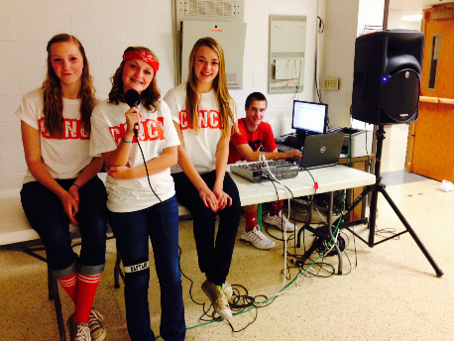
Student’s responsibility:

The student is to follow the Internet Acceptable Use Policy

The student will have full access to the school homepage. The student is to be responsible for posting only what is appropriate and educational

Student goals:

- To be a competent worker in the field of Information Technology
- To gain hands on experience working with a full computer network
- To gain good knowledge of the use and operations of personal computers and related peripheral equipment
- To gain information technology skills to be a more valuable worker in the computer field
- To gain consultation skills such as recommending software purchases through reviews and testing or researching hardware parts for replacement
- To participate in a work setting with job expectations, a supervisor, and co-workers
- To become familiar with working in the computer field and use this knowledge to better decide on a career path to follow
- Improve time management skills to make oneself more productive, for example carrying a tool kit to the repair location, preparing rescue disks to have on hand, listing all technical questions before contacting tech support and more
- To become a better problem solver in being challenged by many different problems that arise with computer software, hardware, and end users that must be resolved and not ignored or let go
- Communicate fluently using technical terms with experts in the field
- Contact technical support through the fastest most efficient means possible such as email, technical support live correspondence, and frequently asked questions
- Gain confidence to be able to take on any new computer request independently and waiting to ask for help when all options have been tried
- Improve personal skills in working with others and appreciating all that others have to offer in return
- To be a good trainer to new hires and act as a mentor as long as needed
- To know how to have a good handshake in a professional setting
- To support the computer program at Cincinnatus Central School and promote its growth

Upon successfully completing this course students will value:

- The importance of lifelong learning due to technological change
- The importance of being computer literate in an information society
- The worth of his or her work and the work of others
- Their own ideas, beliefs, and opinions as well as those of others
- Technology as a tool for gathering information
- Technology as a tool for productivity in any working environment
- Technology as a tool for effective communication on a local, regional, and an international level
- The importance of producing quality presentation documents to accomplish successful results
- The importance of attendance and punctuality
- The importance of optimism and enthusiasm in completing a task
- The importance of responsible behavior to an organization or team
- The importance of managing one's time to be a more productive worker
- The role in helping other more novice learners in improving their skills

Evaluations

- Students are expected to constantly evaluate their work both while in progress and when completed
- Students are to work off a ticket entered online by end users and daily to do list on the office white board by either closing tickets online or checking off jobs on the list when completed
- Student’s work will be assessed using a bi-weekly evaluation form and given a progress grade by the Network Administrator/Teacher
- The student will report directly to the network administrator/teacher for daily assignments
- Through evaluations students get feedback to help them learn
- The Network Administrator/Teacher works right alongside the work study students on new or more challenging jobs

Expectations

- To report to work on time and work hard the entire schedule
- Informs appropriate individuals on progress of assignment
- Results are consistently successful
- Skill level is clearly at a computer technician level or higher
- Deadlines are met
- Respect is shown at all times to personnel and end users
- Trustworthy with access given to the school’s network
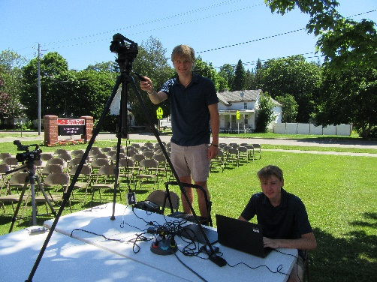
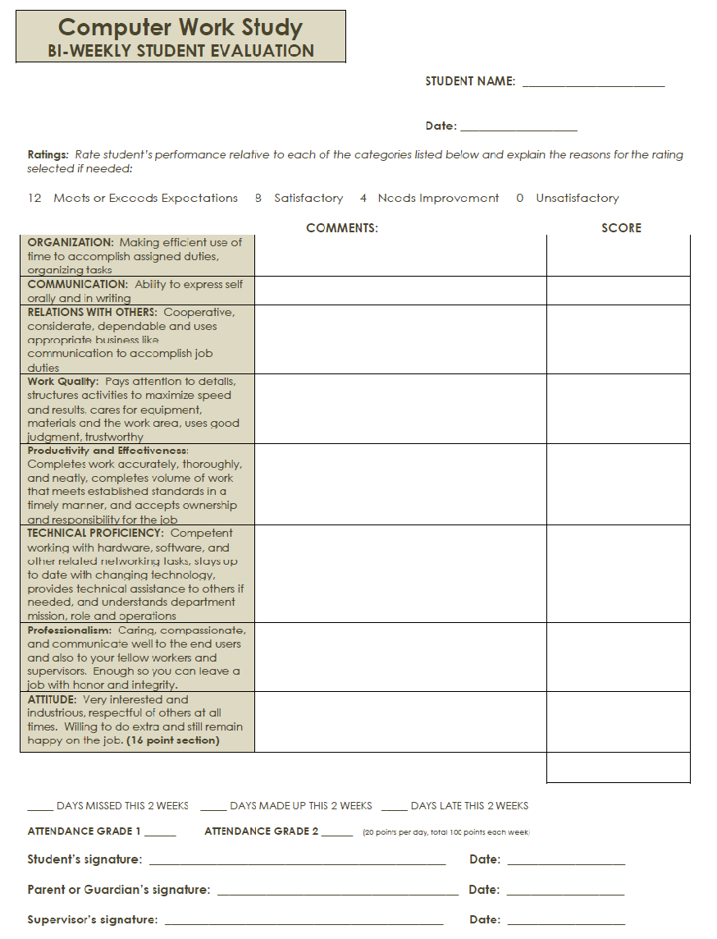
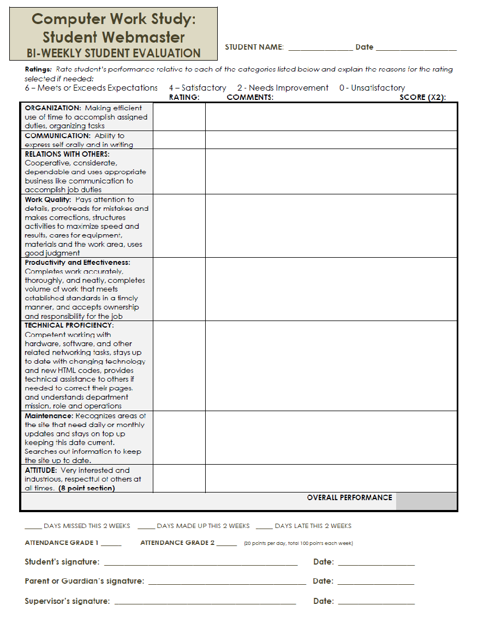
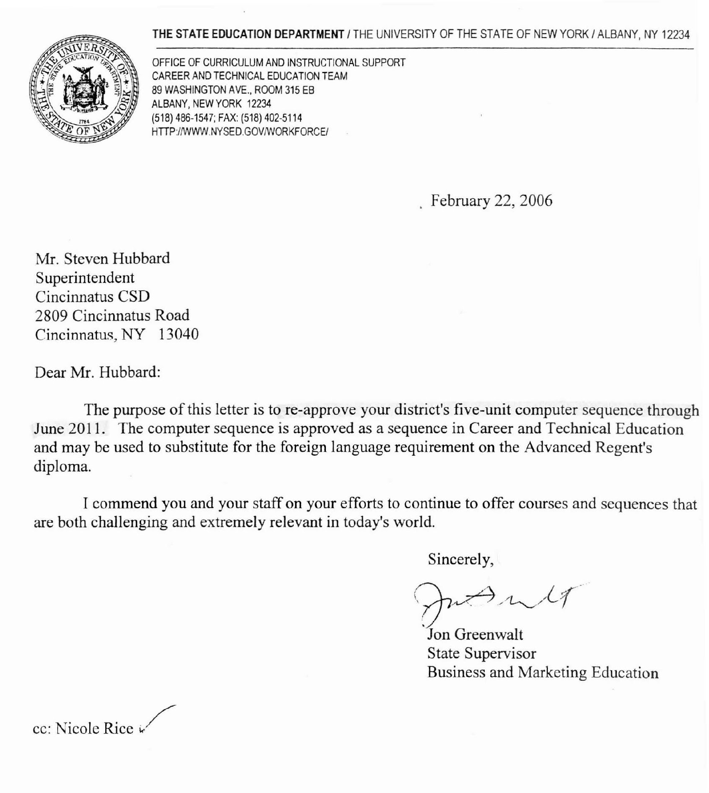
NEW YORK STATE EDUCATION DEPARTMENT FIVE UNIT COMPUTER PROGRAM APPROVAL LETTER

SAMPLE LETTER OF APPROVAL after 2011, the state no longer required letters.
SAMPLE JOB POSTING

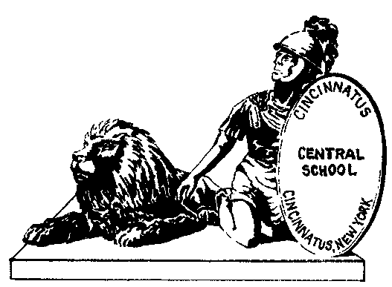

Cincinnatus Central School Telephone (607) 863-3200
2809 Cincinnatus Road Fax (607) 863-3200
Cincinnatus, New York 13040

Cincinnatus Central School District is seeking outstanding individuals for the following position:

Total Number of Positions: 2
Student Computer Work Study Computer Technician

Requirement:
Must be enrolled as a student in a high school computer class and working on a 3- or 5-unit program in computers

Posting Date: (2 weeks, specific dates listed here)
Schedule and Dates: To be assigned

Letter of interest and a resume should be directed to:
Superintendent of Schools
Attention: Personnel Clerk
2809 Cincinnatus Road
Cincinnatus, NY 13040

INTERVIEW SHEET FOR STUDENTS TO USE WHEN INTERVIEWING NEW STUDENT CANDIDATES

Interview Sheet

Each Question is worth 10 points
 | 60 | 65 | 70 | 75 | 80 | 85 | 90 | 95 | 100
Greeting and eye contact | 1 | 1.5 | 2 | 2.5 | 3 | 3.5 | 4 | 4.5 | 5
How punctual was the student? | 1 | 1.5 | 2 | 2.5 | 3 | 3.5 | 4 | 4.5 | 5
Handshake (Firm not fishy, did they reach out first?) | 1 | 1.5 | 2 | 2.5 | 3 | 3.5 | 4 | 4.5 | 5
Eye contact throughout the Interview and showed respect | 1 | 1.5 | 2 | 2.5 | 3 | 3.5 | 4 | 4.5 | 5
Was the student dressed appropriate for the interview? | 1 | 1.5 | 2 | 2.5 | 3 | 3.5 | 4 | 4.5 | 5
How well did the student do encouraging you to select them? | 1 | 1.5 | 2 | 2.5 | 3 | 3.5 | 4 | 4.5 | 5
How prepared was the student to answer your questions? | 1 | 1.5 | 2 | 2.5 | 3 | 3.5 | 4 | 4.5 | 5
Did the applicant have questions to ask of you the interviewer about the job? | 1 | 1.5 | 2 | 2.5 | 3 | 3.5 | 4 | 4.5 | 5
Technical background beyond computer classes | 1 | 1.5 | 2 | 2.5 | 3 | 3.5 | 4 | 4.5 | 5
Notes: | Total:
 | X2

Would you hire this person? ____________ points Grad Total

10 points for yes
5 points for maybe (maybe = you’ll have to see other applicants first)
0 points for no

Comments:

SAMPLE RECOMMENDATION FOR HIRE MEMO

Memo
To: Superintendent of Schools
From: Technology Coordinator
Date: (Month, Day, Year here)
Re: Student Computer Work Study Computer Technician Vacancy
CC: Personnel Office

To fill the opening for a student computer work study computer technician, posted (date here), I would like to recommend (student’s name here). The student’s six-week internship period would be (date start and end here).

The student will be entering 9th grade for the (date here) school year and will be enrolled in a computer course as part of a 3- or 5-unit computer program.

